You should have the following information handy.

Hostname, Path to install, Path of cdunix file, /tmp should have exec (mount |grep tmp)

/tmp should not have noexec



Before starting installation make sure you have a /cdinstall separate mount point for dumps transfer and installation. Also the rights should be with cduser. Always install with cduser.

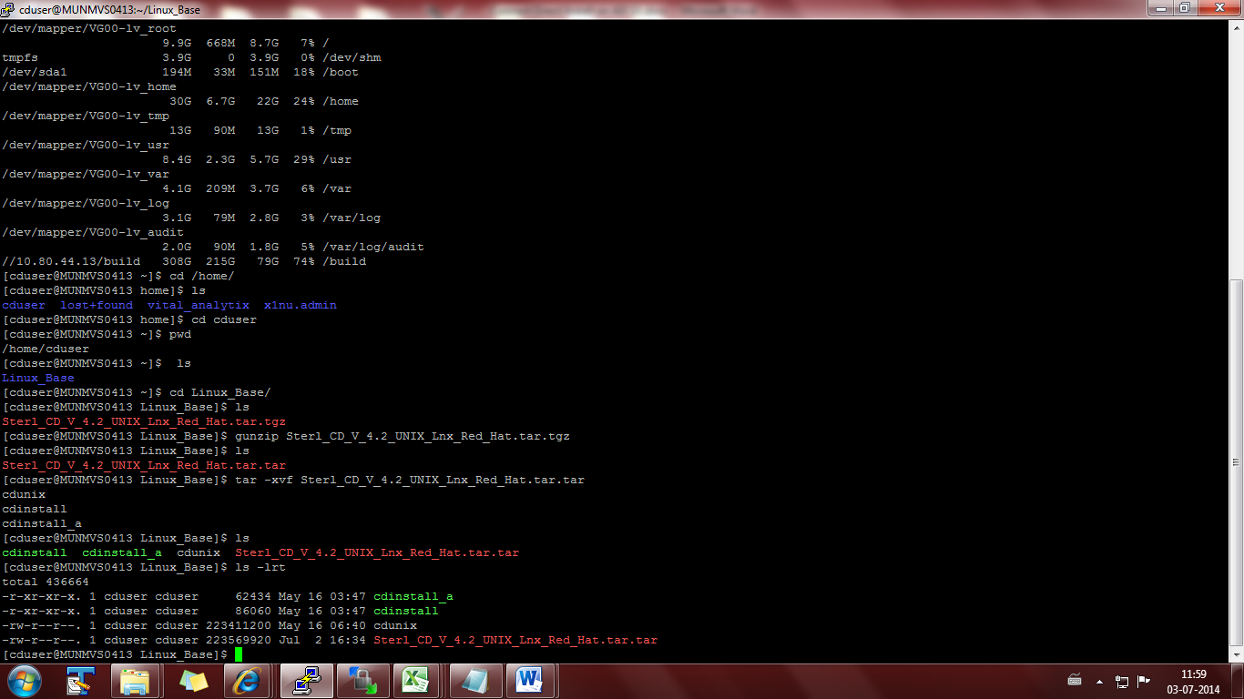

1. Unzip the tar file and run ./cdinstall from Linux_Base directory.

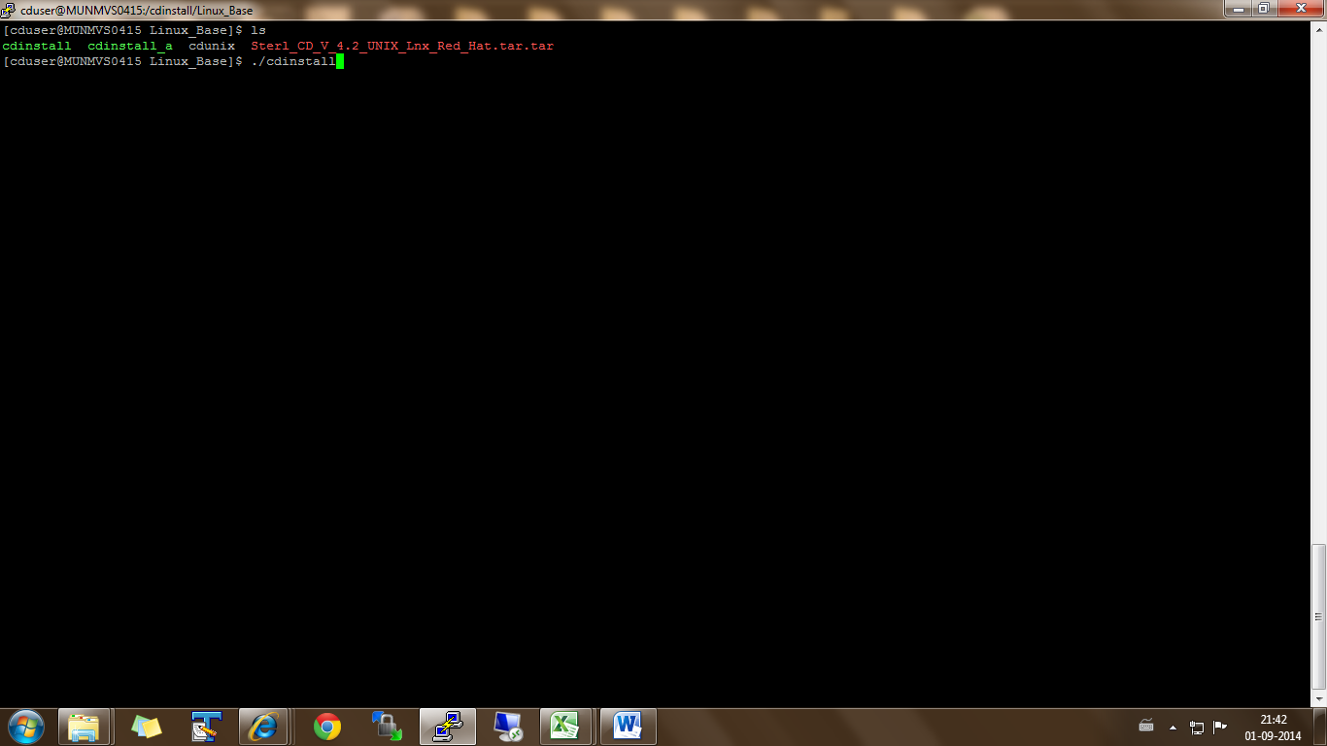

1. Press Enter.

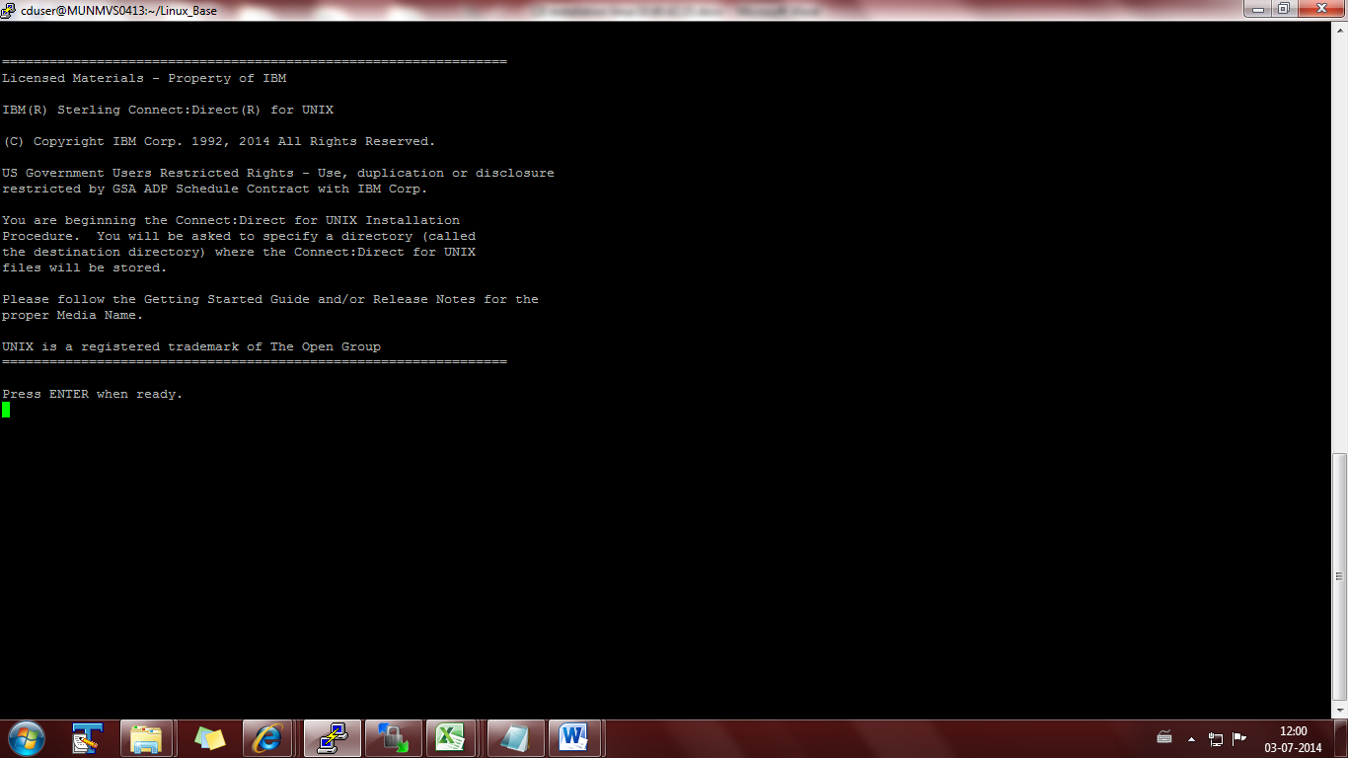

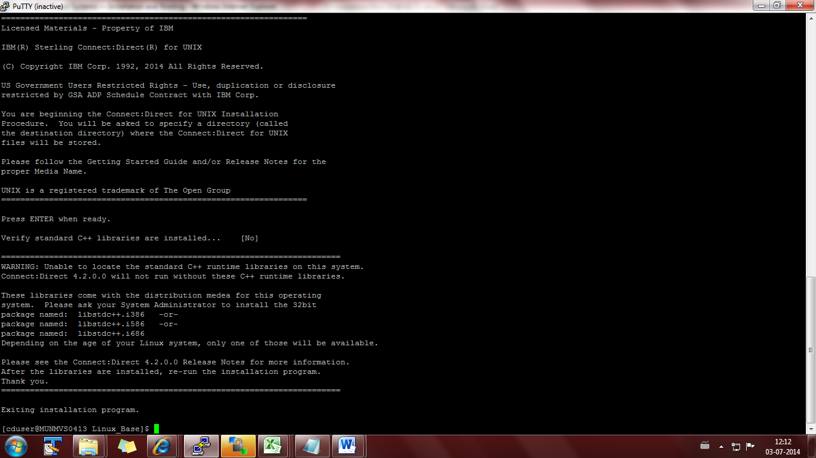

Install prerequisites :

These libraries come with the distribution medea for this operating

system. Please ask your System Administrator to install the 32bit

package named: libstdc++.i386 -or-

package named: libstdc++.i586 -or-

package named: libstdc++.i686

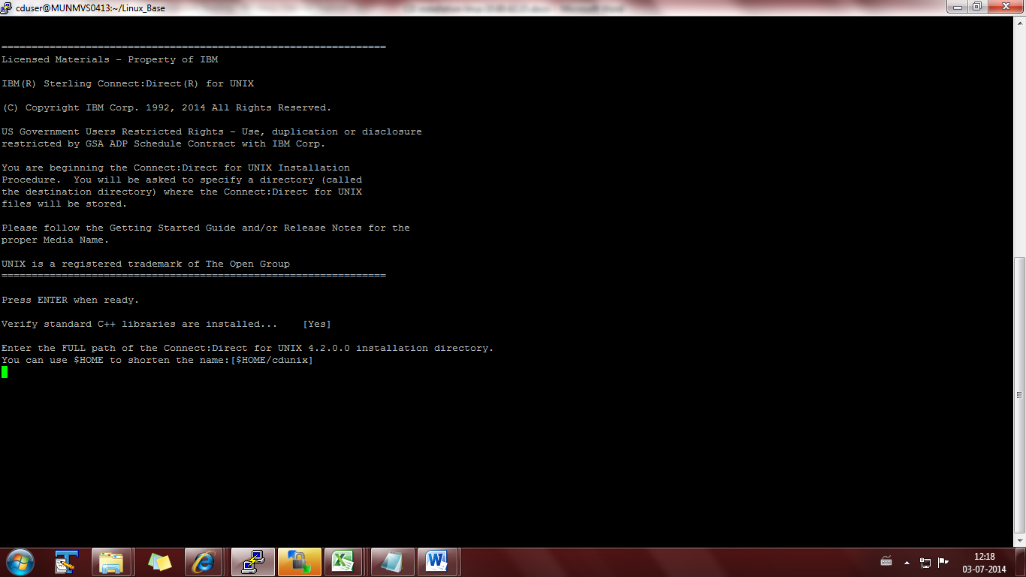

1. Enter the Path for CD installation/

/cdinstall

Press enter and [Y]

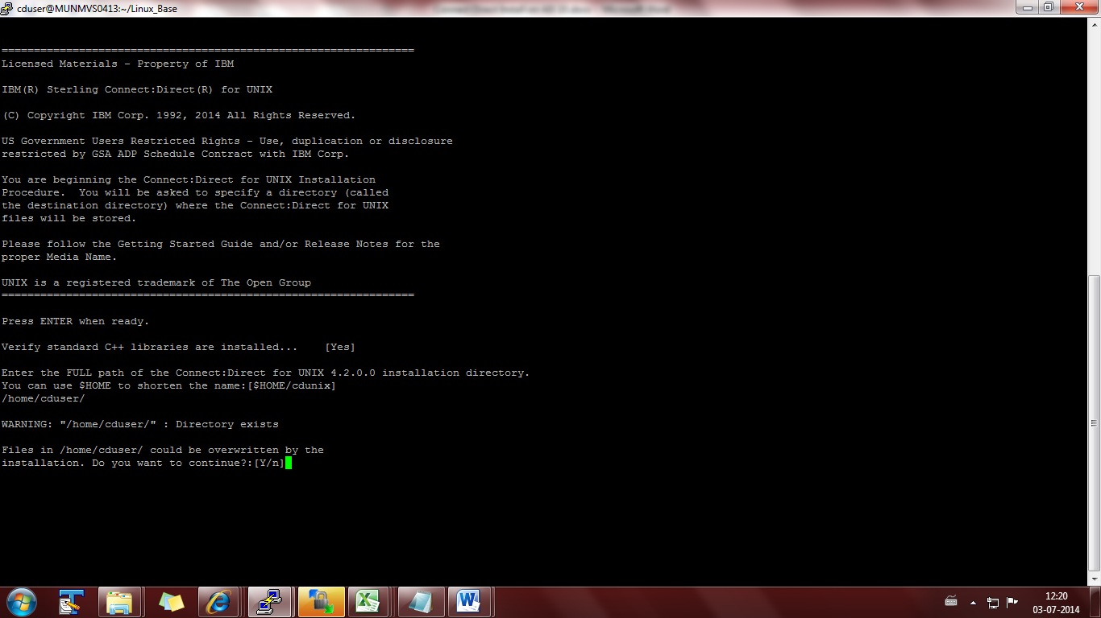

1. Enter 1.

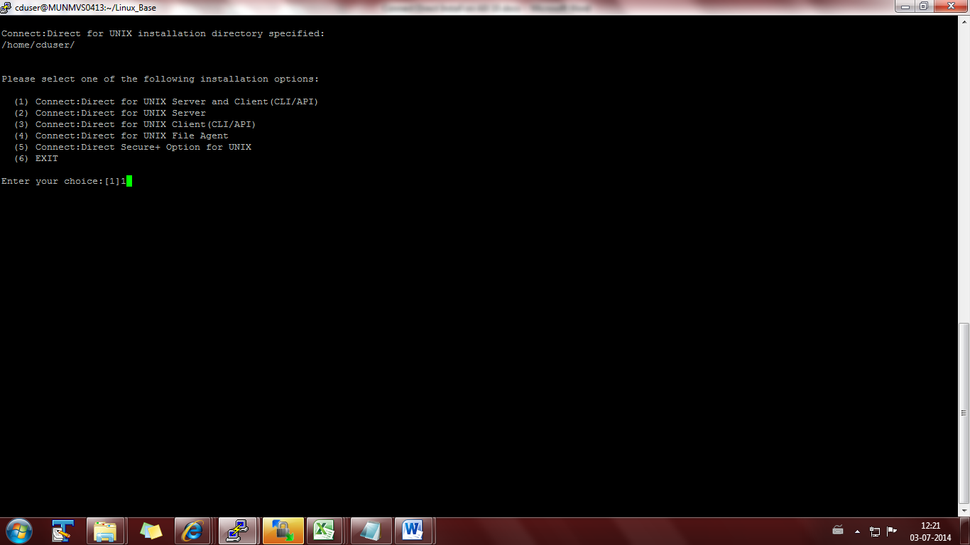

1. Give the path of cdunix where tar is extracted:

/cdinstall/software_cd/Linux_Base/cdunix

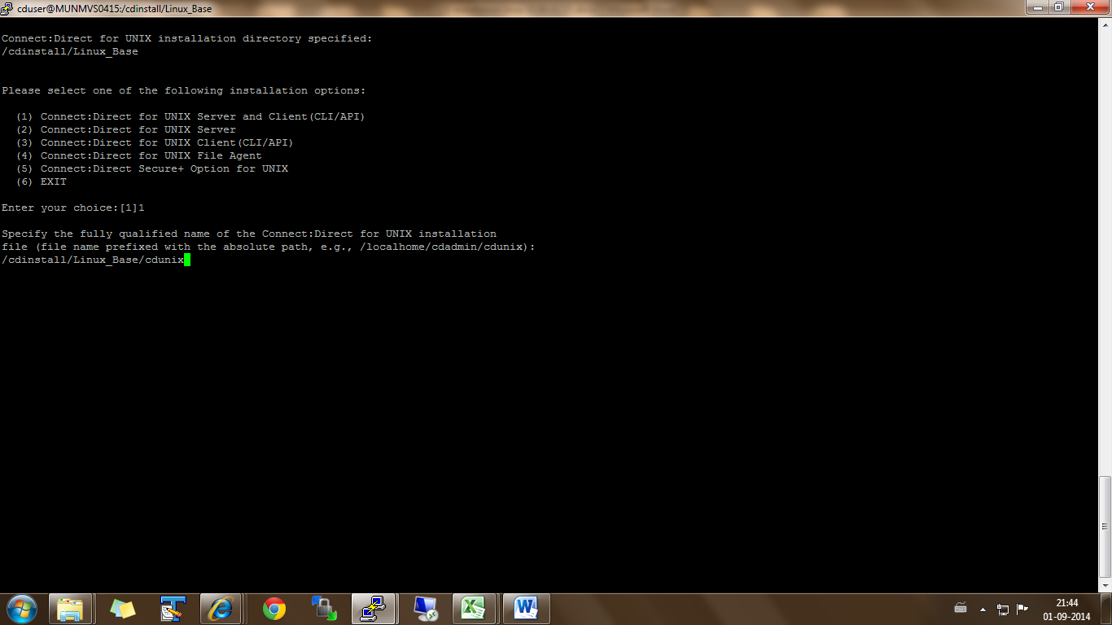

1. Enter [Y]

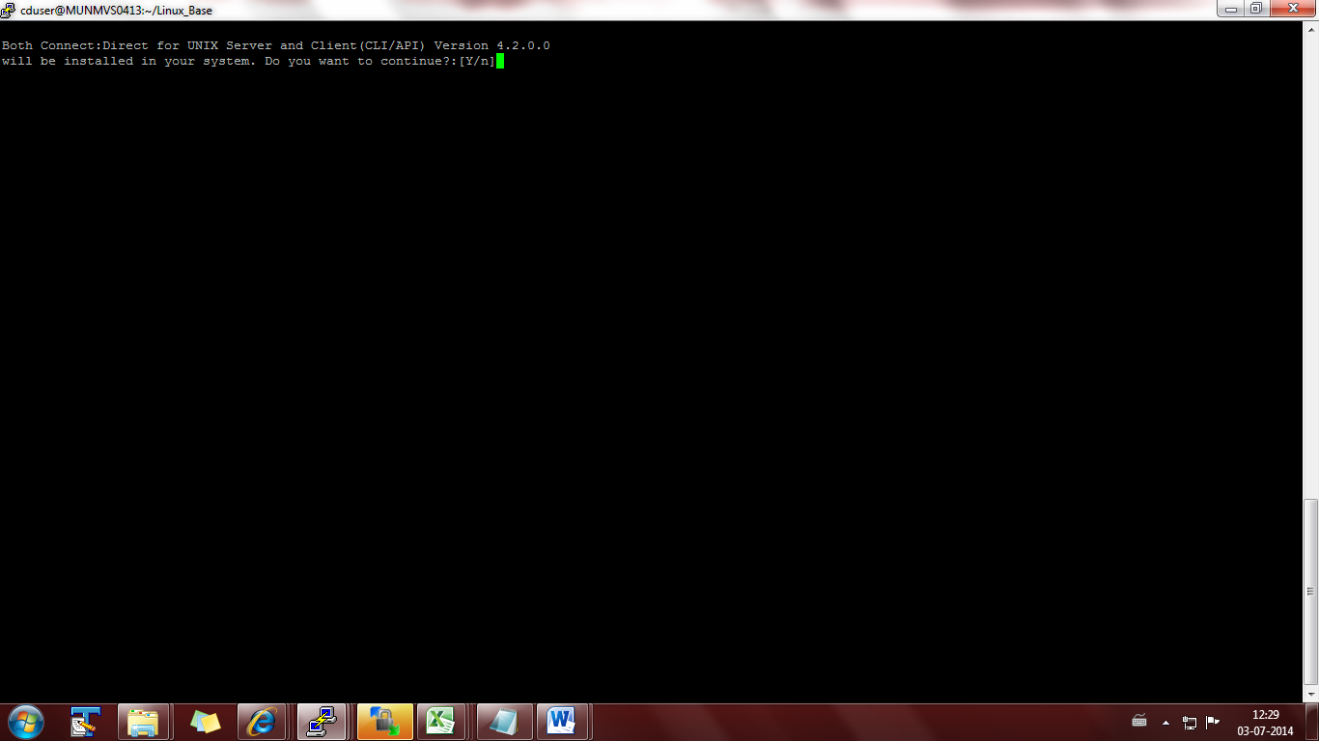

1. Enter 3.

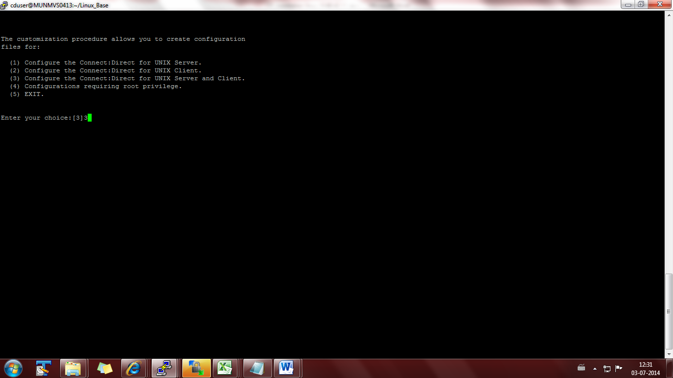

1. Enter the Hostname.

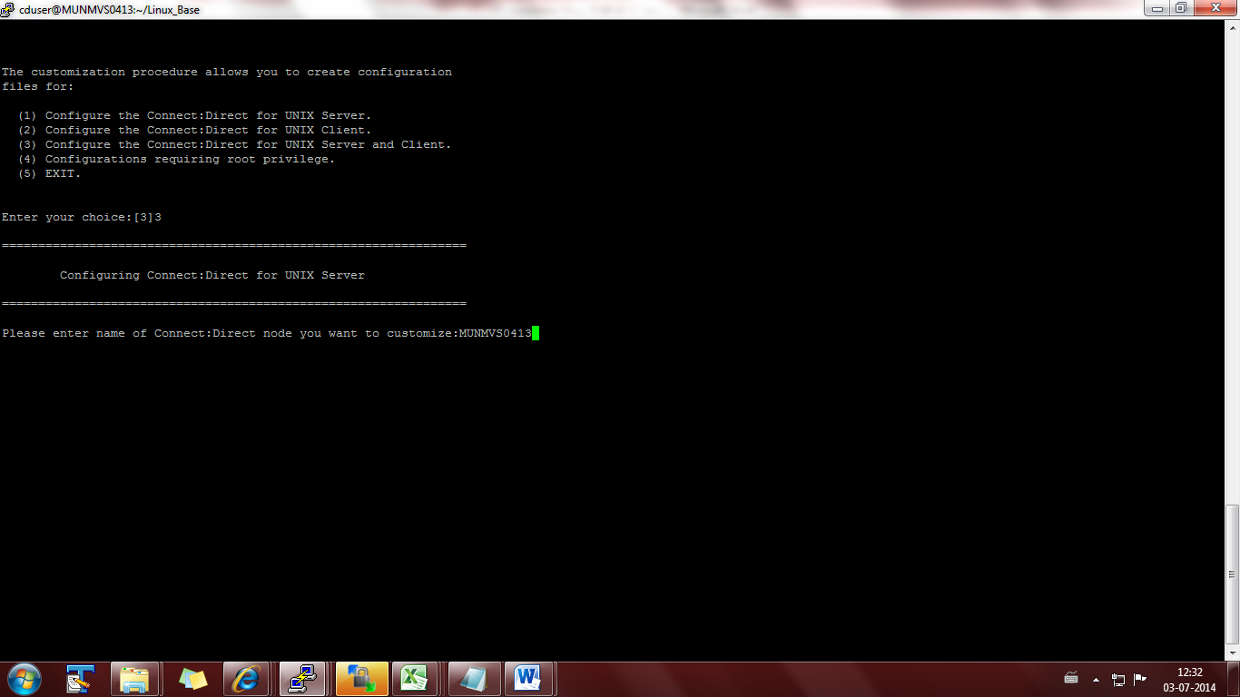

1. Press enter for all below 4 options

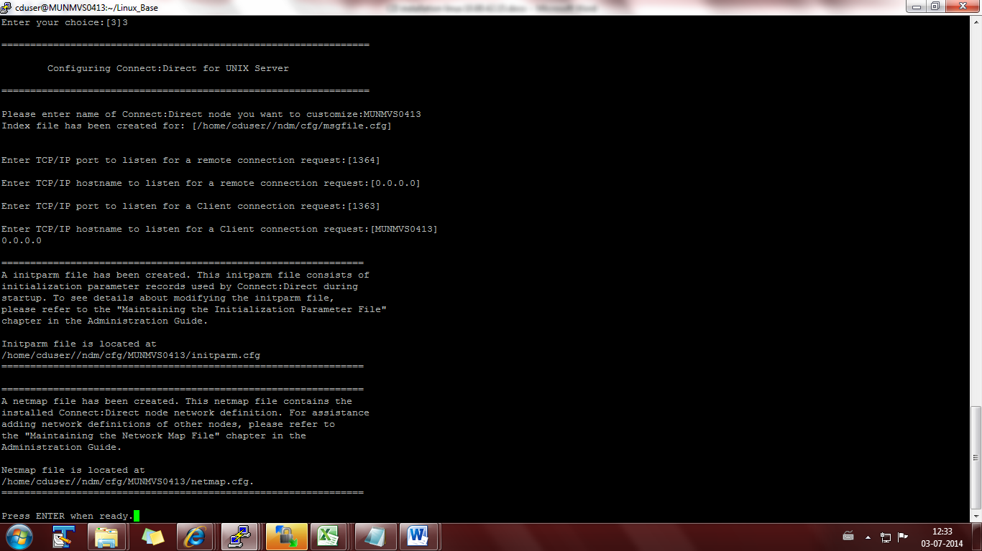

1. Enter [N] for remote user. Enter [Y] for local user.\

Userid: cduser. Grant Administrative Authority [Y]

Insert another local user record [N].

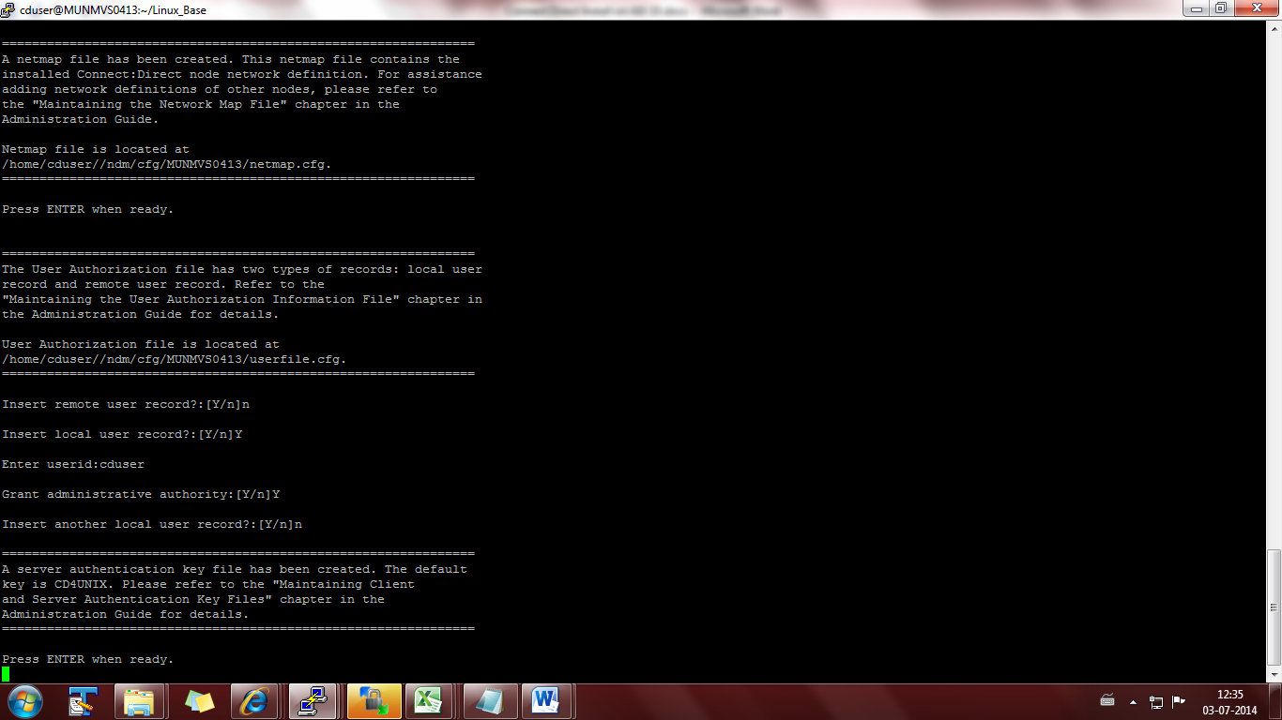

1. Press 4 and enter.

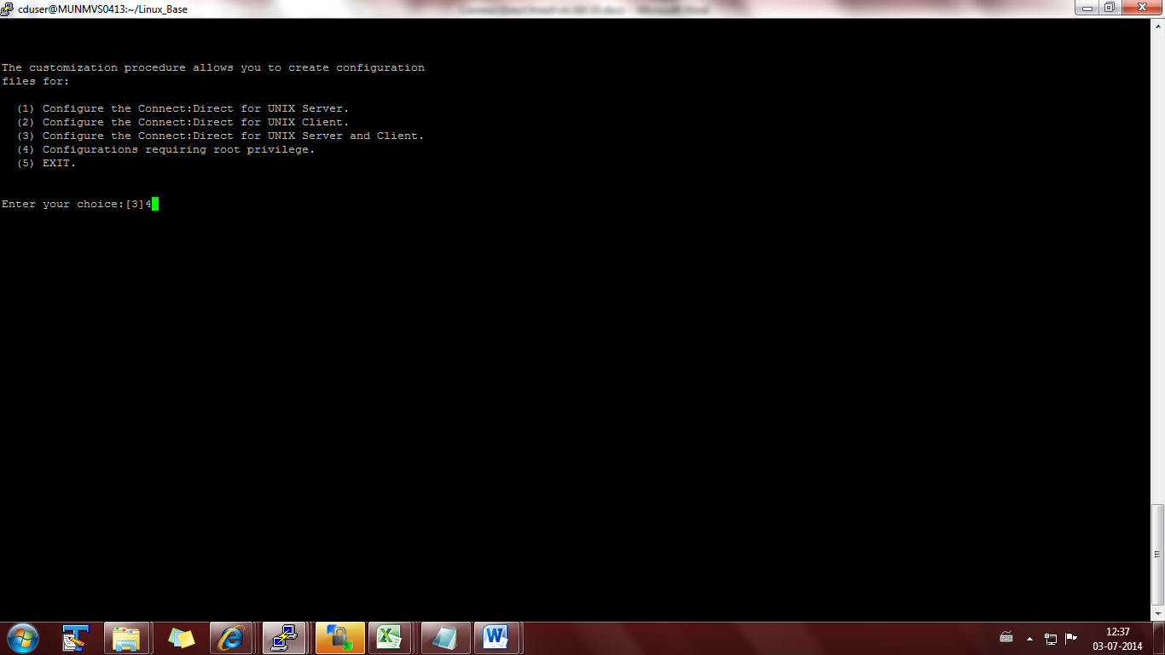

1. Press [Y] for root password and enter the password.

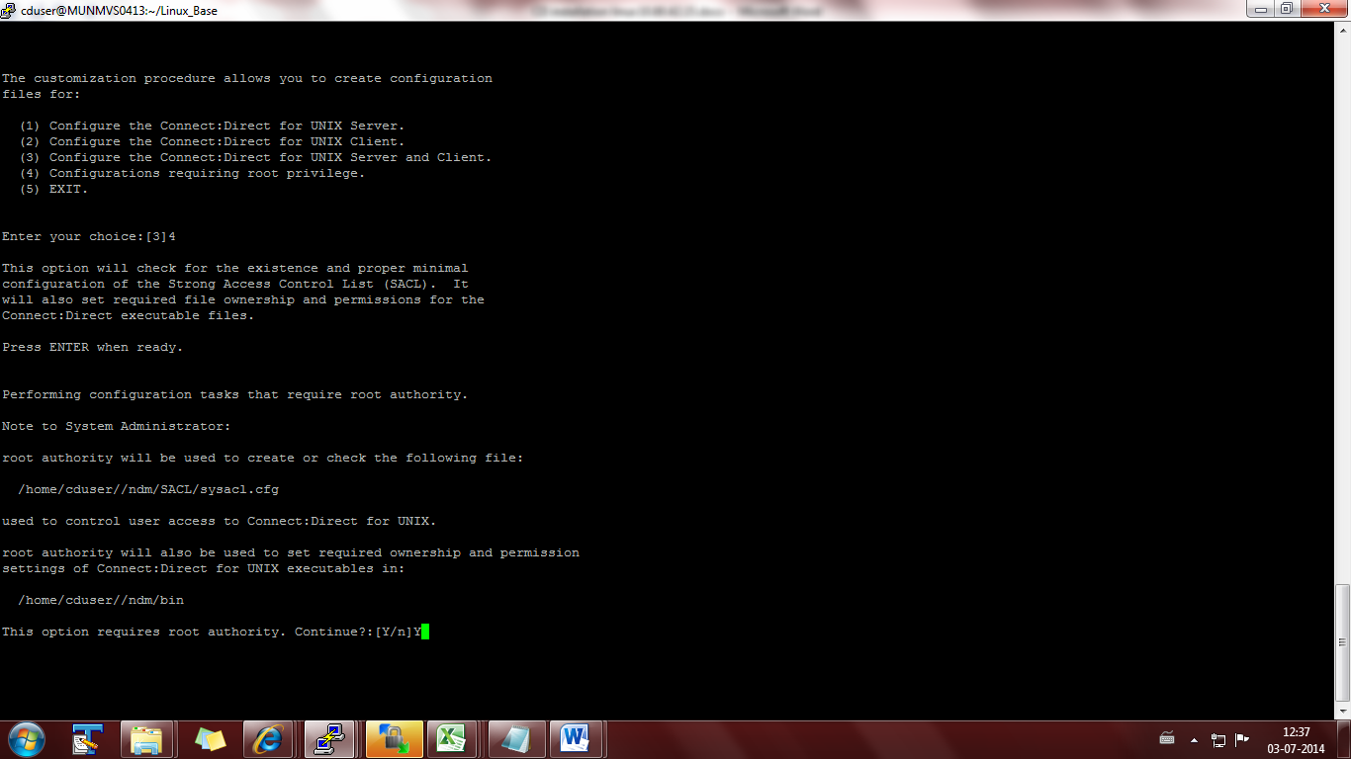

1. Press 3 and enter.

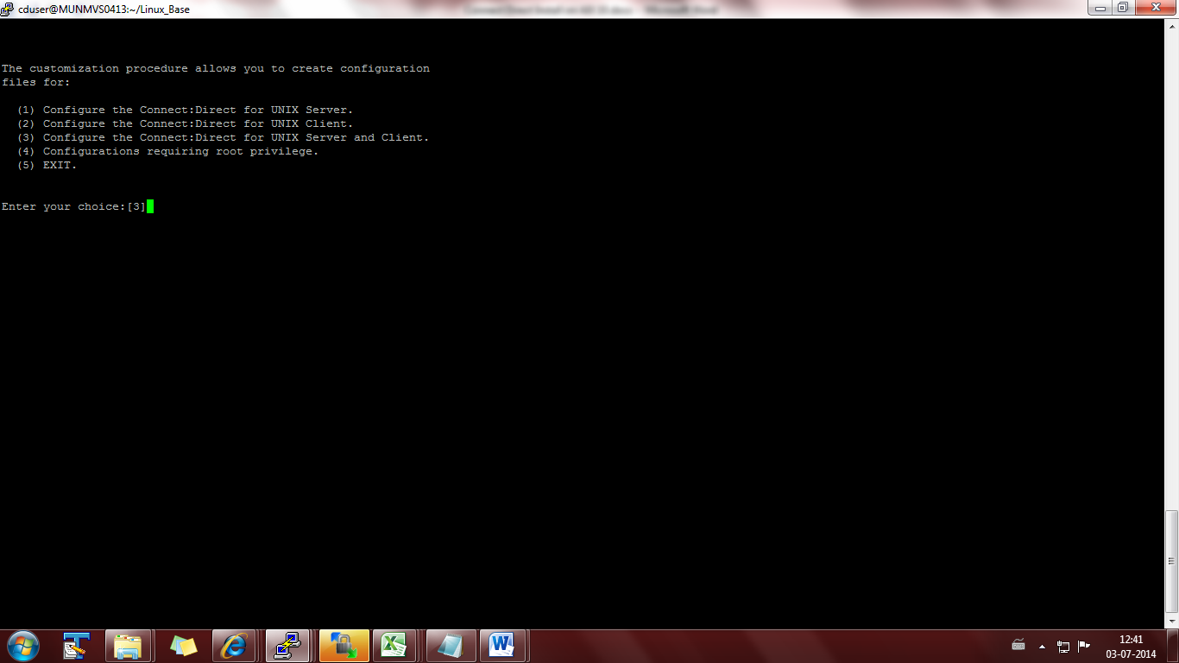

1. Press 5 after al installation steps are completed successfully.

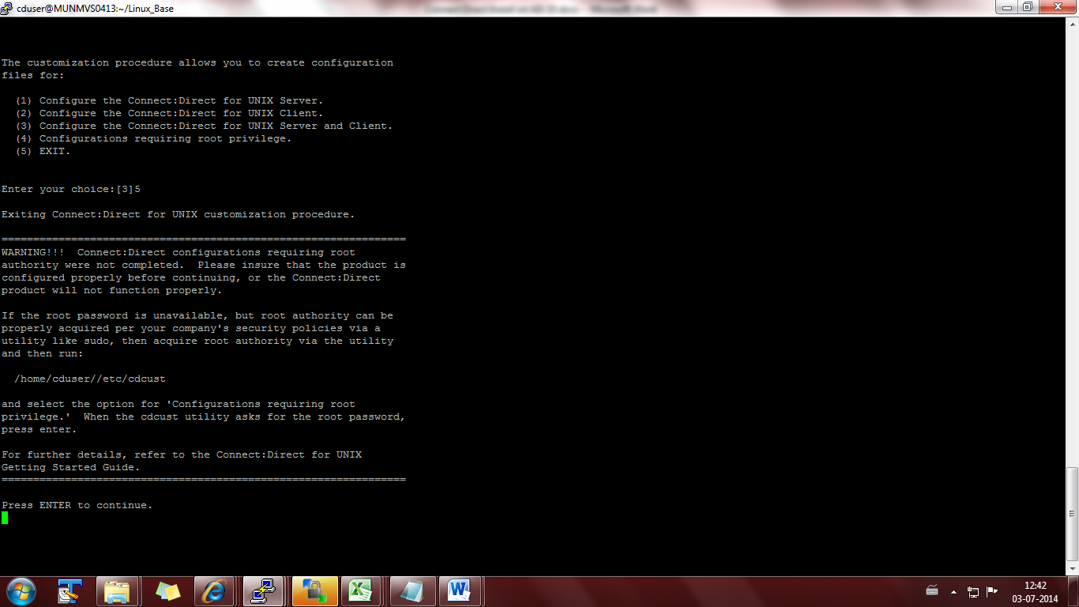

CDbrowser installation:

